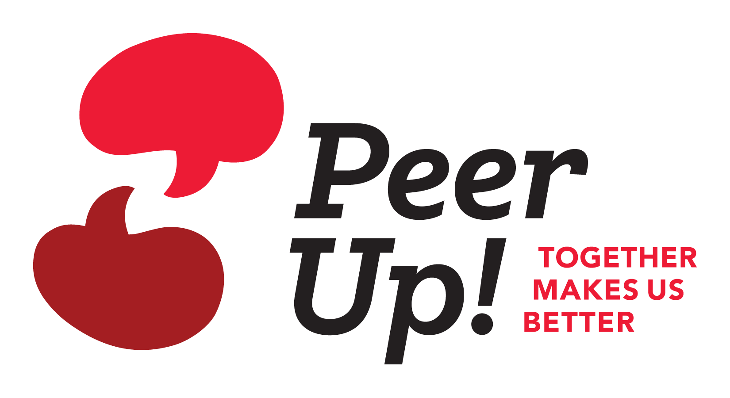

### Then the Peer Up! program might be for you!

Peer Up! is an exciting, new peer mentoring program starting here at our facility. It is designed to help dialysis patients support and learn from each other so they can take better care of themselves.

### Then the Peer Up! program might be for you!

Peer Up! is an exciting, new peer mentoring program starting here at our facility. It is designed to help dialysis patients support and learn from each other so they can take better care of themselves.

### Then the Peer Up! program might be for you!

Peer Up! is an exciting, new peer mentoring program starting here at our facility. It is designed to help dialysis patients support and learn from each other so they can take better care of themselves.

### Then the Peer Up! program might be for you!

Peer Up! is an exciting, new peer mentoring program starting here at our facility. It is designed to help dialysis patients support and learn from each other so they can take better care of themselves.

## Ever wanted to help others by sharing your own experiences with kidney disease?

# Ever wished you could talk to someone who knows what it is like to be on dialysis?

This document was developed under CMS Contract #HHSM-500-2013-NW005C. The contents of this document do not necessarily reflect CMS policy.

TO LEARN MORE ABOUT THE PROGRAM, CONTACT   
[INSERT NAME OF FACILITY CONTACT HERE].